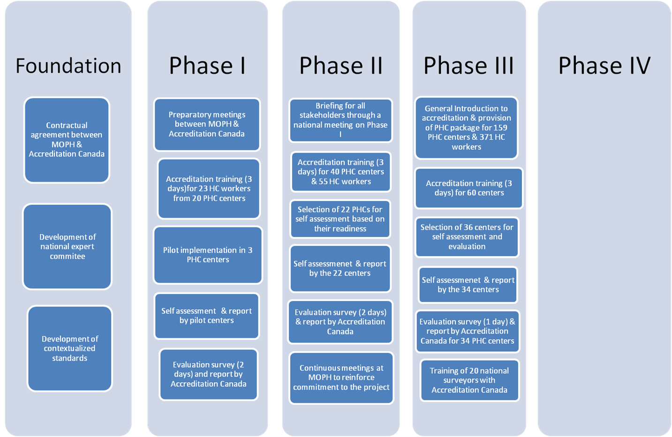

2008-2010

2010-2011

2011-2012

2013-2014

2015

Prepare 10 PHC centers for Actual survey by Accreditation Canada

Self-assessment for 20 PHC centers and Mock survey visit

Develop system for Accreditation Decision & Claim Accreditation System

Theory and Practicum Training for 16 National Surveyors

Train 30 PHC centers (60 Health Care Workers)

Capacity Building for 60 Accreditation Coordinators

Update Accreditation Standards

Figure 1. Phases of Primary Health Care Accreditation Process in Lebanon